Chapter 1: Introduction
  - Brief overview of the work:
The AI-Enhanced Decentralized Identity Verification System is a secure, privacy-focused digital identity platform that allows users to create, own, and verify their identities without relying on centralized authorities. The system leverages Self-Sovereign Identity (SSI) principles, blockchain-based trust, and AI-driven biometric and document verification to ensure authenticity while keeping personal data under user control.

Unlike traditional identity systems that store sensitive information on centralized servers, this platform stores identity credentials securely in user-controlled wallets and uses blockchain only for immutable cryptographic proofs. AI enhances the verification process through face recognition, liveness detection, and fraud prevention, enabling fast and reliable identity validation. The system is designed to support real-world use cases such as digital KYC, e-governance, education, and secure online access.

  - Objective:
- User-Owned Digital Identity Management: Design and implement a self-sovereign identity framework that allows users to create, own, and manage their digital identities through secure wallets, ensuring complete control over personal data without dependence on centralized authorities.
- Decentralized Trust Using Blockchain: Utilize blockchain technology to store immutable cryptographic proofs and credential hashes, enabling tamper-proof identity verification while avoiding on-chain storage of sensitive user information.
- AI-Driven Identity Verification and Fraud Prevention: Incorporate artificial intelligence techniques such as facial recognition, liveness detection, and document analysis to automate identity verification and prevent impersonation, forgery, and deepfake-based attacks.
- Verifiable Credential Issuance and Validation: Enable trusted issuers such as government bodies, educational institutions, or organizations to issue digitally signed verifiable credentials that users can securely store and selectively share with verifiers.
- Consent-Based and Privacy-Preserving Verification: Implement selective disclosure mechanisms that allow users to share only the required identity attributes during verification, ensuring privacy while maintaining verification accuracy.
- Secure Off-Chain Data Storage: Store identity documents and sensitive data in encrypted off-chain storage systems, using blockchain only as a verification and audit layer to ensure scalability and compliance with data protection standards.
- Scalable Verification for Real-World Use Cases: Support identity verification for domains such as banking, digital KYC, e-governance, education, and online platforms, enabling fast and reusable verification across multiple services.
- Modular and Extensible System Architecture: Design a modular architecture that separates identity management, AI verification, blockchain services, and storage layers, allowing future enhancements such as zero-knowledge proofs, cross-chain identity, or biometric extensions.
  - Scope:
The AI-Enhanced Decentralized Identity Verification System is a secure, web-based platform designed to enable privacy-preserving identity creation, management, and verification using Self-Sovereign Identity principles. The system allows users to own and control their digital identities while enabling trusted organizations to verify identity claims through blockchain-based proofs and AI-driven validation mechanisms. It eliminates centralized data storage and repetitive verification processes, making digital identity verification more secure, efficient, and scalable.
Key Aspects of the Project Scope :
- Decentralized Identity Creation and Management:
  - Enable users to generate Decentralized Identifiers (DIDs) and manage their digital identities through encrypted identity wallets.
  - Provide full user ownership and control over identity credentials without dependency on centralized identity providers.
- Verifiable Credential Issuance and Storage:
  - Allow trusted issuers such as governments, universities, or organizations to issue digitally signed verifiable credentials.
  - Store credentials securely in user-controlled wallets and encrypted off-chain storage systems.
- Blockchain-Based Trust and Auditability:
  - Use blockchain technology to store immutable cryptographic proofs, credential hashes, and revocation status.
  - Ensure tamper-proof verification and transparent audit trails without exposing sensitive personal data on-chain.
- AI-Driven Identity Verification and Fraud Detection:
  - Integrate AI techniques such as facial recognition, liveness detection, and document analysis for automated identity validation.
  - Detect fraudulent attempts including impersonation, forged documents, and deepfake-based attacks.
- Consent-Based and Privacy-Preserving Verification:
  - Implement selective disclosure mechanisms that allow users to share only the required identity attributes during verification.
  - Ensure explicit user consent before any credential is shared with a verifier.
- Secure Off-Chain Data Storage:
  - Store identity documents and biometric data in encrypted off-chain storage systems such as secure cloud storage or decentralized file systems.
  - Use blockchain solely as a verification layer to maintain compliance with privacy and data protection regulations.
- Cross-Platform and Web-Based Accessibility:
  - Develop the system as a browser-based application accessible across modern devices without additional installations.
  - Ensure a consistent and secure user experience for individuals, issuers, and verifiers.
- Scalability and Extensibility:
  - Design a modular architecture that supports integration of future technologies such as zero-knowledge proofs, cross-chain identity, and biometric extensions.
  - Enable the system to scale efficiently for large numbers of users, issuers, and verification requests.

  - Project Modules :
1.4.1 User Authentication & Wallet Integration Module: This module is responsible for secure user authentication using blockchain wallets. It enables users to connect their crypto wallets (such as MetaMask), authenticate via cryptographic signatures, and establish secure sessions. Nonce-based signature verification ensures resistance against replay attacks, while JWT-based session management maintains authenticated access. The module also handles wallet disconnection events and session expiration to maintain system security.

1.4.2 Decentralized Identifier (DID) Management Module: The DID Management Module handles the creation, registration, resolution, and lifecycle management of decentralized identifiers. It generates DIDs from wallet addresses, creates DID documents, registers them on the blockchain, and supports retrieval and updates. This module ensures that each user has a unique, verifiable, and blockchain-anchored digital identity with controlled status management.

1.4.3 Document Management Module: This module manages the secure handling of user identity documents such as passports and national IDs. It supports document upload, validation, encryption, decentralized storage using IPFS, retrieval, versioning, and deletion. Strong encryption ensures confidentiality, while IPFS integration guarantees tamper resistance and availability of identity documents.

1.4.4 AI-Powered Verification Module: The AI-Powered Verification Module performs automated identity verification using artificial intelligence techniques. It includes facial recognition, liveness detection, OCR-based data extraction, and document authenticity validation. A composite scoring mechanism evaluates multiple verification signals to determine identity validity, significantly reducing fraud and manual intervention.

1.4.5 Credential Management Module: This module manages the full lifecycle of verifiable credentials. It enables credential issuance, hashing, blockchain anchoring, retrieval, validation, revocation, and expiry handling. Credentials issued through this module are cryptographically secure, verifiable, and reusable across different services while remaining under user control.

1.4.6 Selective Disclosure & QR Code Module: The Selective Disclosure Module allows users to share only specific identity attributes required for verification. It supports QR-code–based credential sharing with time-limited access and detailed access logging. This module ensures privacy-preserving identity verification while enabling fast, offline, or device-to-device verification.

1.4.7 Blockchain Integration Module: This module provides the core blockchain interaction layer of the system. It manages smart contract deployment, transaction execution, event listening, gas optimization, and multi-network support. The module ensures reliable communication between off-chain services and on-chain identity registries.

1.4.8 User Dashboard & Interface Module: The User Interface Module provides a user-friendly web interface for identity management and verification workflows. It includes dashboards, credential viewers, verification wizards, activity logs, and settings management. This module ensures a smooth and intuitive experience for users interacting with decentralized identity services.

1.4.9 Admin & Management Module: The Admin Module enables system administrators to manage users, configurations, verification reviews, and support requests. It provides dashboards, reporting tools, and system controls required for operational oversight and maintenance.

  - Project Hardware/Software Requirements:
Hardware Requirements :
    - Device: Desktop or laptop capable of running modern web applications and AI workloads.
    - Display: Minimum 13” screen with 1366×768 resolution (Recommended: Full HD or higher).
    - CPU: Minimum Intel Core i3 or equivalent (Recommended: Intel Core i5/i7 or AMD Ryzen 5/7).
    - RAM: At least 4 GB (Recommended: 8 GB or more for smooth AI processing and multitasking).
    - Storage: Minimum 20 GB free disk space for development tools, dependencies, and data storage.
    - Internet Connection: Stable broadband connection (minimum 5 Mbps recommended for blockchain and API interactions).
    - Peripherals: Webcam required for biometric verification (face recognition and liveness detection).

Software Requirements :
• Operating System: Windows 10/11, macOS (Catalina or later), or Linux (Ubuntu 20.04+).
• Development Environment:
- Programming Language: JavaScript / TypeScript, Python
- IDE: Visual Studio Code
- Version Control: Git (optional but recommended)
• Libraries and Tools:
- Frontend: React.js, Next.js, TailwindCSS
- Backend & APIs: Node.js (Express / NestJS), REST APIs
- Blockchain Technologies: Ethereum / Polygon (Testnet), Solidity
- Storage & Database: MongoDB, IPFS

Chapter 2: Literature review
- Decentralized Identifiers and Self-Sovereign Identity
Authors: W3C Decentralized Identifier Working Group
Published In: W3C Recommendation (2022)
Summary: This specification introduces Decentralized Identifiers (DIDs) as a new type of identifier that enables verifiable, decentralized digital identity. The document defines DID syntax, DID documents, and resolution mechanisms that allow identities to be controlled by users rather than centralized authorities. It establishes the foundation for Self-Sovereign Identity (SSI) systems by removing dependency on central identity providers.
Relevance: This work forms the core theoretical foundation of the proposed system by defining how decentralized identities are created, resolved, and managed. The project directly adopts W3C DID standards to ensure interoperability and compliance with global identity frameworks.

  - Blockchain-Based Digital Identity Management
Authors: Ferdous, Chowdhury, and Alassafi
Published In: IEEE Access (2019)
Summary: The paper presents a comprehensive survey of blockchain-based identity management systems. It discusses how blockchain can be used to ensure immutability, transparency, and decentralized trust in identity verification while highlighting challenges such as privacy, scalability, and data storage limitations.
Relevance: This study supports the use of blockchain as a trust layer rather than a data storage mechanism. The proposed system follows this approach by storing only cryptographic hashes and verification proofs on-chain, addressing the privacy and scalability concerns discussed in the paper.

  - Verifiable Credentials for Secure Identity Sharing
Authors: Reed et al
Published In: IEEE Security & Privacy Magazine (2020)
Summary: This paper introduces the concept of verifiable credentials, where identity claims are digitally signed by trusted issuers and can be independently verified without contacting the issuer. It emphasizes selective disclosure and user consent as key mechanisms for privacy-preserving identity verification.
Relevance: The project adopts verifiable credentials as a primary method for identity proof exchange. The selective disclosure mechanism described in this work directly influences the design of the credential sharing and QR-based verification features of the system.

  - Biometric Authentication and Liveness Detection Using AI
Authors: Galbally, Marcel, and Fierrez
Published In: IEEE Transactions on Information Forensics and Security (2014)
Summary: This research explores biometric authentication techniques and the importance of liveness detection in preventing spoofing attacks such as photo, video, and replay attacks. It analyzes various face recognition and liveness detection methods used in secure identity verification systems.
Relevance: This paper justifies the integration of AI-based facial recognition and liveness detection in the proposed system to prevent impersonation and deepfake-based fraud during identity verification.

Chapter 3: System Analysis & Design
- Comparison of Existing Applications with your Application:
Feature | Centralized KYC / National ID (e.g., banks, Aadhaar) | Existing SSI Platforms (Sovrin / Polygon ID / Civic) | AI-Enhanced DID System (proposed)
Who controls identity | Central authorities / provider-controlled (issuer + custodian). | User-first / holder-controlled DIDs. | User-owned wallets + DIDs (SSI). Users control credentials and sharing.
Where data lives | Personal data stored centrally (databases); documents often held by provider → higher breach risk. | Minimal on-chain; credentials held by user; some platforms use on-chain anchors or ZK proofs. | Off-chain encrypted storage for documents (IPFS/cloud); only hashes/proofs on-chain.
Verification method | Provider-driven KYC checks, manual or centralized automated checks. | Cryptographic VC verification (DID + VC), sometimes ZK proofs (Polygon ID). | VC verification + AI biometric/document checks (face match, liveness, OCR) before/alongside cryptographic checks.
Privacy & selective disclosure | Low - providers typically require full documents and store data. | High - selective disclosure is supported, especially with ZK approaches (Polygon ID). | High - selective disclosure + QR/time-limited proofs + ZKP-friendly design; user consent enforced.
Fraud / spoof protection | Relies on back-office checks; vulnerable to forged docs and centralized breaches. | Cryptographic integrity reduces some fraud; fewer active anti-deepfake measures out of the box. | Active AI fraud detection (liveness, forgery detection, composite scoring) + cryptographic proofs.
Revocation / auditability | Revocation handled internally (blacklists); audit trails centralized. | On-chain revocation/status models supported via registries/ledgers. | On-chain credential hash + revocation lists; auditable blockchain logs plus off-chain audit logs.
Scalability & cost | Scales but incurs heavy infra and compliance costs; central ops overhead. | Many SSI projects use testnets or permissioned ledgers to manage cost | Hybrid design: low on-chain storage (low gas), off-chain scalable storage
Regulatory readiness | Mature for compliance (banks, gov) but raises privacy concerns (centralized risk). | Emerging; some pilots and govt interest, but adoption varies. | Designed for compliance (consent, minimal on-chain PII); may require legal/regulatory onboarding for banks/gov.
Table 3.1: Comparative Analysis of Existing Systems
  - Project feasibility study :
    - Technical Feasibility: The proposed system is technically feasible as it is built using modern, well-supported technologies such as blockchain platforms, web frameworks, and AI libraries. Decentralized identity standards like DIDs and Verifiable Credentials are already defined by W3C and are supported by existing blockchain networks. AI-based face verification, liveness detection, and document analysis can be implemented using open-source machine learning frameworks. The modular architecture ensures scalability, easy maintenance, and smooth integration of future enhancements.
    - Operational Feasibility: The proposed AI-Enhanced Decentralized Identity Verification System is operationally feasible as it is designed to integrate smoothly into existing digital workflows without requiring major changes to user behavior or organizational processes. The system provides a user-friendly web interface that allows individuals to manage their identities and complete verification steps with minimal technical knowledge. Automated AI-based verification and blockchain-backed validation reduce manual intervention, making day-to-day operations efficient and reliable.
    - Economic Feasibility: The project is economically feasible as it relies primarily on open-source tools, blockchain test networks, and free or low-cost development platforms. There are minimal infrastructure costs during development, and cloud resources can be scaled based on usage. The system also has strong commercial potential in areas such as digital KYC, banking, e-governance, and education, making it viable for future real-world deployment.

3.3 Project Timeline chart:

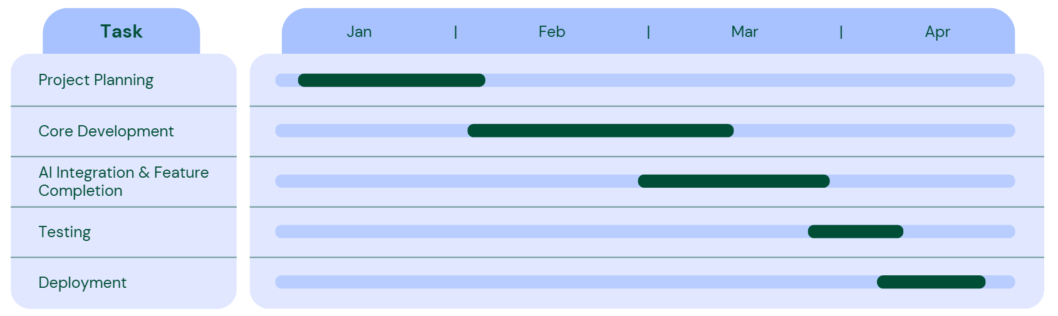
Figure 3.1: Project Timeline Chart

3.4 Detailed Modules Description:

3.4.1 User Authentication & Wallet Integration Module

Purpose:
To authenticate users securely using blockchain wallets and establish trusted user sessions without traditional username–password mechanisms.

Working Methodology:
- The user connects a blockchain wallet (e.g., MetaMask) to the application.
- The system generates a unique nonce and requests the user to sign it using their wallet’s private key.
- The signed message is verified on the backend to confirm wallet ownership.
- Upon successful verification, a JWT token is generated for session management.
- The module continuously monitors wallet connection status and invalidates sessions on disconnect.

Expected Output:
- Secure user login without passwords
- Verified wallet ownership
- Active authenticated user session

3.4.2 Decentralized Identifier (DID) Management Module

Purpose:
To create, register, manage, and resolve decentralized identifiers that uniquely represent users in the system.

Working Methodology:
- A DID is generated from the user’s wallet address using standardized DID methods.
- A DID document containing public keys and service endpoints is created.
- The DID and its metadata are registered on the blockchain via a smart contract.
- DID resolution retrieves the DID document for verification or updates.
- DID status (active/inactive) is maintained to support revocation or suspension.

Expected Output:
- Unique blockchain-registered DID for each user
- Resolvable DID document
- Verified decentralized identity

3.4.3 Document Management Module

Purpose:
To securely handle identity documents required for verification while preserving privacy.

Working Methodology:
- Users upload identity documents such as passport or national ID.
- Files are validated for format and size.
- Documents are encrypted using AES-256 encryption.
- Encrypted files are stored in IPFS or secure off-chain storage.
- Document hashes are generated for integrity verification.
- Versioning allows tracking of document updates.

Expected Output:
- Securely stored encrypted documents
- IPFS content identifiers (CIDs)
- Tamper-proof document integrity

3.4.4 AI-Powered Verification Module

Purpose:
To automatically verify user identity and prevent fraud using artificial intelligence.

Working Methodology:
- Face verification compares live camera input with ID photo using deep learning models.
- Liveness detection ensures the user is physically present (blink, motion checks).
- OCR extracts textual data from identity documents.
- Document authenticity checks detect tampering or forgery.
- A composite verification score is generated based on all AI checks.

Expected Output:
- AI verification result (Pass / Fail)
- Confidence score for identity validity
- Fraud detection alerts

3.4.5 Credential Management Module

Purpose:
To issue, manage, validate, and revoke verifiable credentials.

Working Methodology:
- After successful verification, a verifiable credential is created.
- Credential data is hashed and digitally signed by the issuer.
- The hash is stored on the blockchain for immutability.
- Credentials are stored in the user’s wallet.
- Revocation and expiry mechanisms update credential status on blockchain.

Expected Output:
- Digitally signed verifiable credentials
- Blockchain-anchored credential proofs
- Valid or revoked credential status

3.4.6 Selective Disclosure & QR Code Module

Purpose:
To allow privacy-preserving sharing of identity attributes.

Working Methodology:
- Users select specific attributes to share (e.g., age, citizenship).
- A QR code is generated encoding the selected credential proof.
- QR codes are time-limited to prevent misuse.
- Verifiers scan and validate the QR code against blockchain proofs.
- All access events are logged for audit purposes.

Expected Output:
- QR-based credential sharing
- Partial identity disclosure
- Secure and auditable verification

3.4.7 Blockchain Integration Module

Purpose:
To provide decentralized trust and immutability using blockchain.

Working Methodology:
- Smart contracts are deployed for DID and credential registries.
- Transactions are executed for DID registration and credential anchoring.
- Event listeners monitor contract updates.
- Gas optimization techniques reduce transaction cost.
- Multi-network support allows testnet and mainnet usage.

Expected Output:
- Immutable blockchain records
- Trusted credential verification
- Transparent audit trail

3.4.8 User Dashboard & Interface Module

Purpose:
To provide an intuitive interface for users to manage identity and verification workflows.

Working Methodology:
- Dashboard displays user identity status and credentials.
- Verification wizard guides users through identity checks.
- Credential viewer allows inspection and sharing of credentials.
- Activity logs display verification history.
- Settings allow user preferences and security controls.

Expected Output:
- User-friendly web interface
- Clear identity and credential visibility
- Smooth verification experience

3.4.9 Admin & Management Module

Purpose:
To provide administrative control over the system.

Working Methodology:
- Admin dashboard manages users and configurations.
- Verification reviews handle exceptional cases.
- Support tickets manage user issues.
- Reports summarize system usage and compliance.

Expected Output:
- Centralized system administration
- Effective system governance

3.5 Project SRS:
3.5.1 Use Case Diagrams:
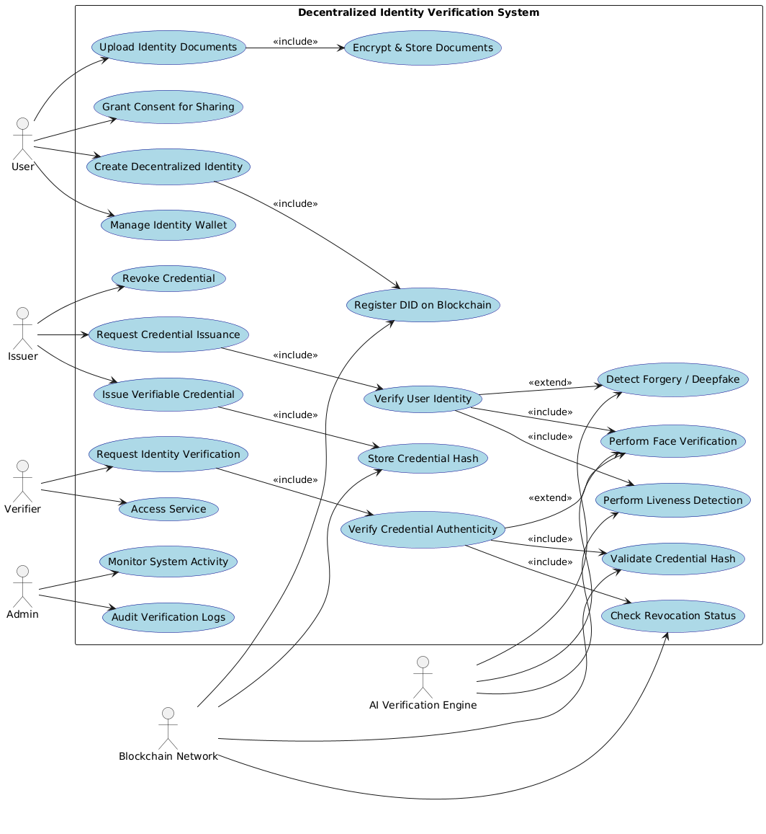
Figure 3.2: Use Case Diagram of DID System

3.5.2 Data Flow Diagrams:
DFD level 0:
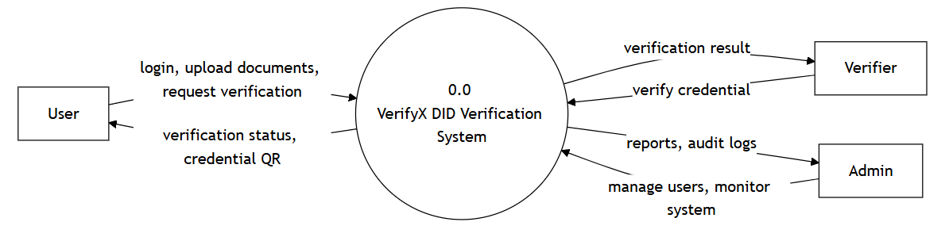
Figure 3.3: Data Flow Diagram Level 0
DFD level 1:
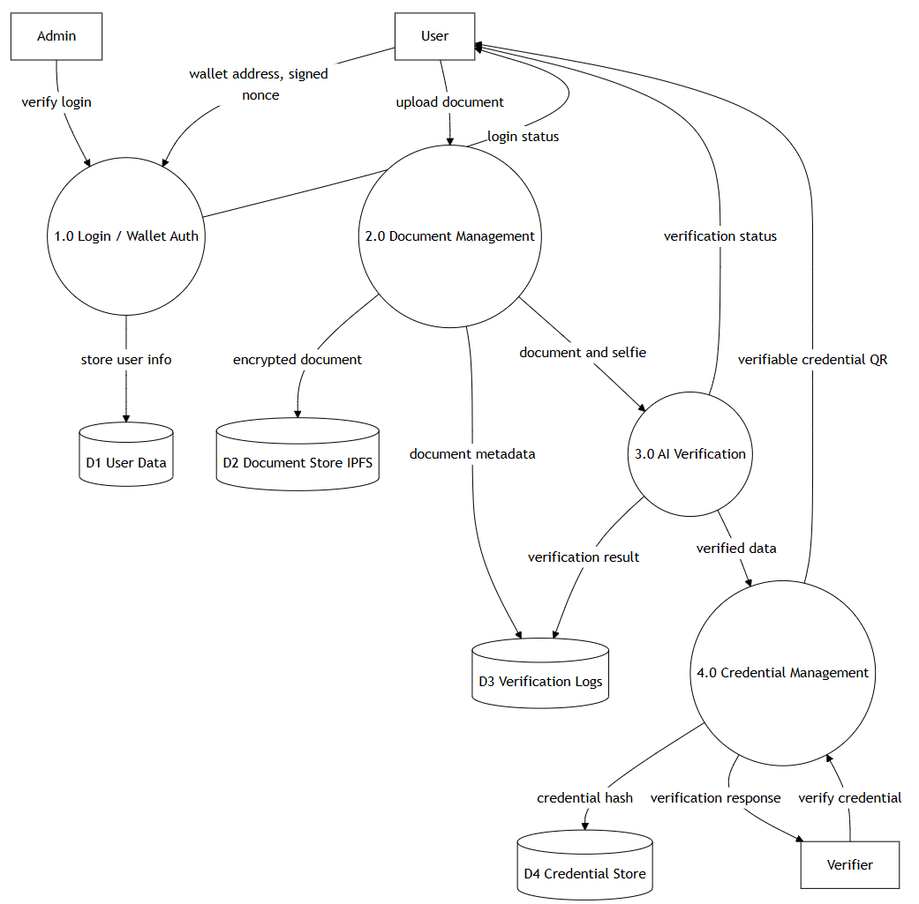
Figure 3.4: Data Flow Diagram Level 1
3.5.3 Class diagram:
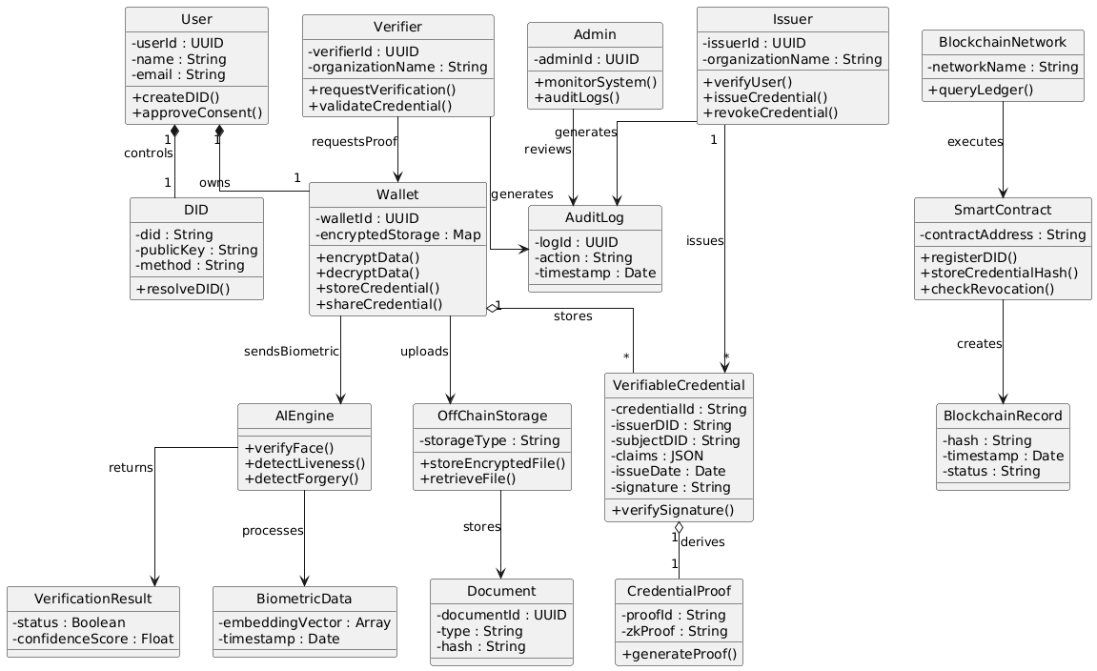
Figure 3.5: Class Diagram

3.5.4 Entity Relationship Diagrams:
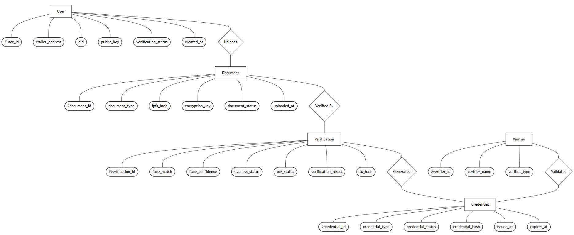
Figure 3.6: Entity Relationship Diagram

3.5.5 Sequence Diagrams:
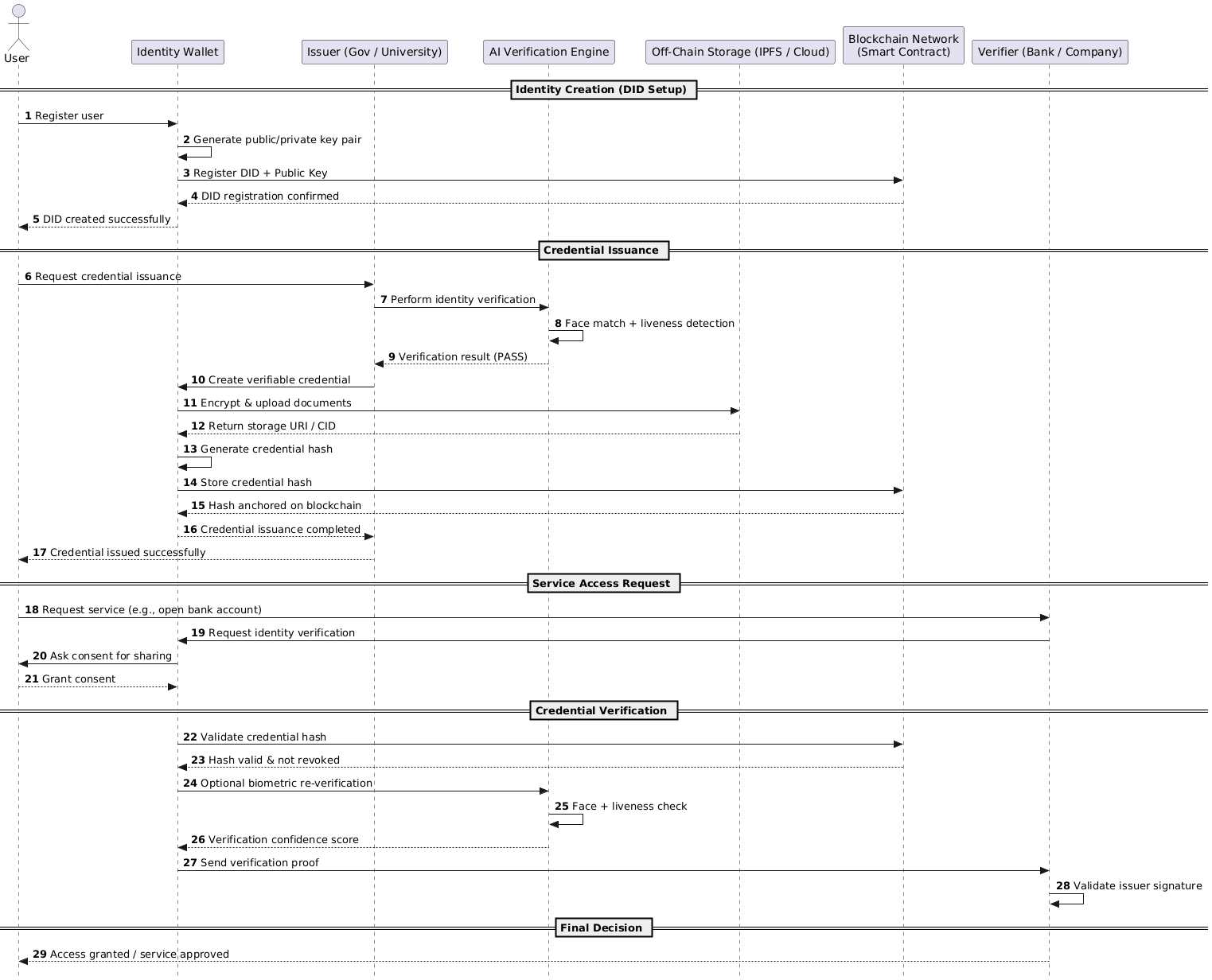
Figure 3.7: Sequence Diagram

3.5.6 State/Activity Diagram:
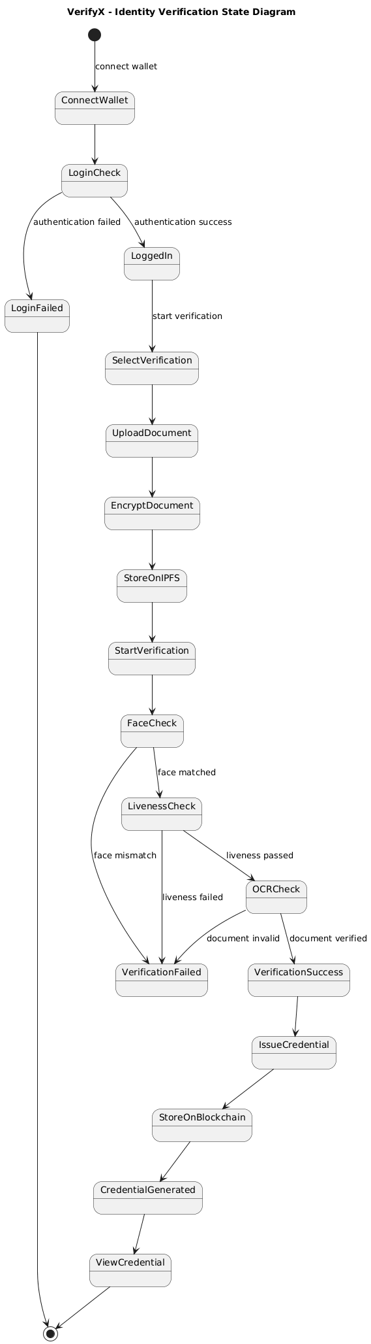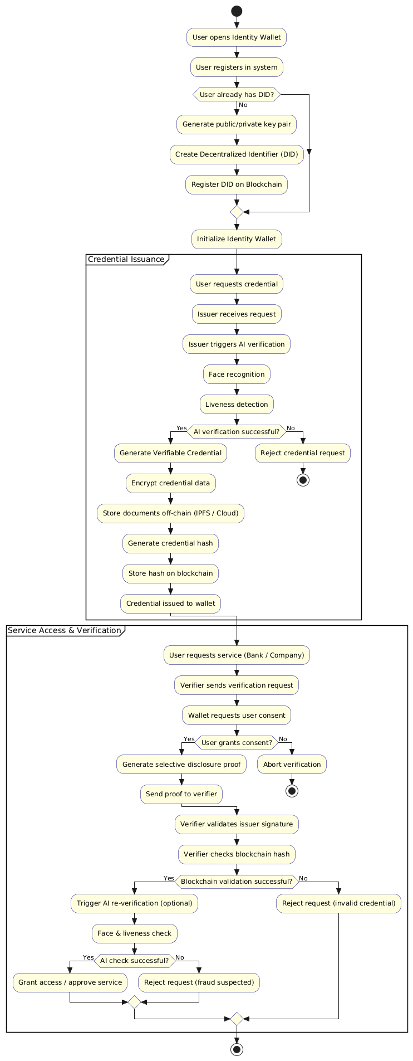
Figure 3.8: State / Activity Diagram

3.6 Data Dictionary:
User Table (MongoDB)
Field Name | Data Type | Description | Constraints
walletAddress | String | Blockchain wallet address of the user | Unique, Not Null
did | String | Decentralized Identifier associated with the user | Unique
publicKey | String | Public cryptographic key derived from wallet | Not Null
createdAt | Date | Account creation timestamp | Auto-generated
lastLogin | Date | Last successful login timestamp | Nullable
verificationStatus | String | Current identity status (pending, verified, rejected) | Enum
credentialIds | Array | List of credential IDs issued to the user | Nullable
Table 3.2: User Collection Data Dictionary

Document Table (MongoDB)
Field Name | Data Type | Description | Constraints
userId | ObjectId | Reference to User collection | Foreign Key
type | String | Document type (passport, driver_license, national_id) | Enum
ipfsHash | String | IPFS content identifier of encrypted document | Unique
encryptionKey | String | Encrypted AES key used for document encryption | Encrypted
status | String | Document status (uploaded, verified, rejected) | Enum
uploadedAt | Date | Document upload timestamp | Auto-generated
verifiedAt | Date | Document verification timestamp | Nullable
Table 3.3: Document Collection Data Dictionary

Verification Table (MongoDB)
Field Name | Data Type | Description | Constraints
userId | ObjectId | Reference to User | Foreign Key
documentId | ObjectId | Reference to Document | Foreign Key
status | String | Verification result (success, failed, pending) | Enum
faceVerification.match | Boolean | Face match result | Not Null
faceVerification.confidence | Number | Face match confidence score | 0–100
faceVerification.model | String | AI model used for face verification | Nullable
livenessDetection.isLive | Boolean | Liveness check result | Not Null
livenessDetection.confidence | Number | Liveness confidence score | 0–100
livenessDetection.challenge | String | Challenge type used | Nullable
documentOCR.extracted | Boolean | OCR success status | Not Null
documentOCR.data | Object | Extracted document fields | Nullable
documentOCR.confidence | Object | Confidence per extracted field | Nullable
credentialHash | String | Hash of issued credential | Unique
blockchainTxHash | String | Blockchain transaction hash | Unique
createdAt | Date | Verification start time | Auto-generated
completedAt | Date | Verification completion time | Nullable
Table 3.4: Verification Collection Data Dictionary

Credential Table (MongoDB)
Field Name | Data Type | Description | Constraints
userId | ObjectId | Reference to User | Foreign Key
verificationId | ObjectId | Reference to Verification | Foreign Key
type | String | Credential type (KYC, Identity, AgeProof) | Enum
status | String | Credential state (active, revoked, expired) | Enum
attributes | Array | Attributes included in credential | Nullable
hash | String | Credential hash stored on blockchain | Unique
blockchainTxHash | String | Blockchain transaction hash | Unique
issuedAt | Date | Credential issue timestamp | Auto-generated
expiresAt | Date | Credential expiration date | Nullable
Table 3.5: Credential Collection Data Dictionary

DID Registry Contract
Field Name | Data Type | Description
controller | address | Wallet address controlling the DID
publicKey | string | Public key linked to the DID
createdAt | uint256 | DID creation timestamp
isActive | bool | DID active/inactive status
Table 3.6: DID Registry Contract Structure

Credential Registry Contract
Field Name | Data Type | Description
credentialHash | bytes32 | Hash of verifiable credential
issuer | address | Issuer wallet address
subject | address | Credential owner wallet
issuedAt | uint256 | Issue timestamp
expiresAt | uint256 | Expiration timestamp
isRevoked | bool | Revocation status
Table 3.7: Credential Registry Contract Structure

Chapter 4: Implementation and Testing
4.1 User Interface and Snapshot:
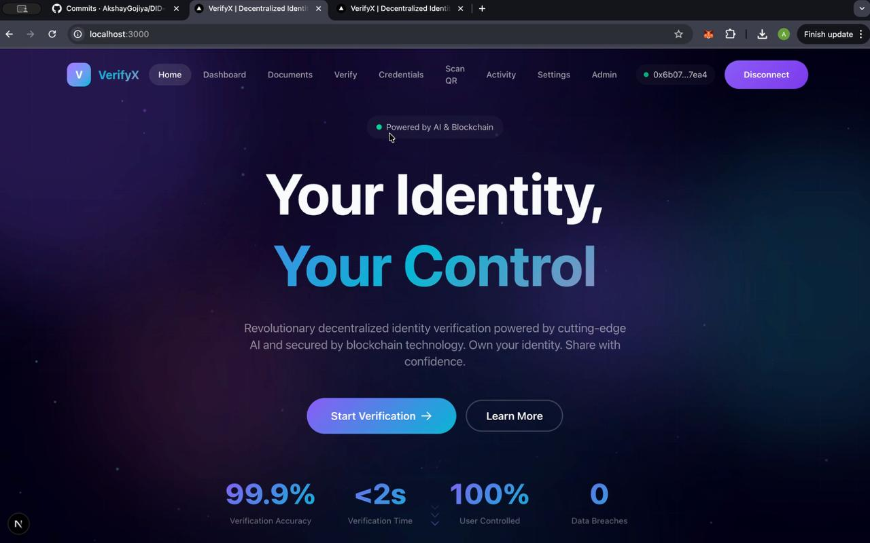
Figure 4.1: Landing Page Interface
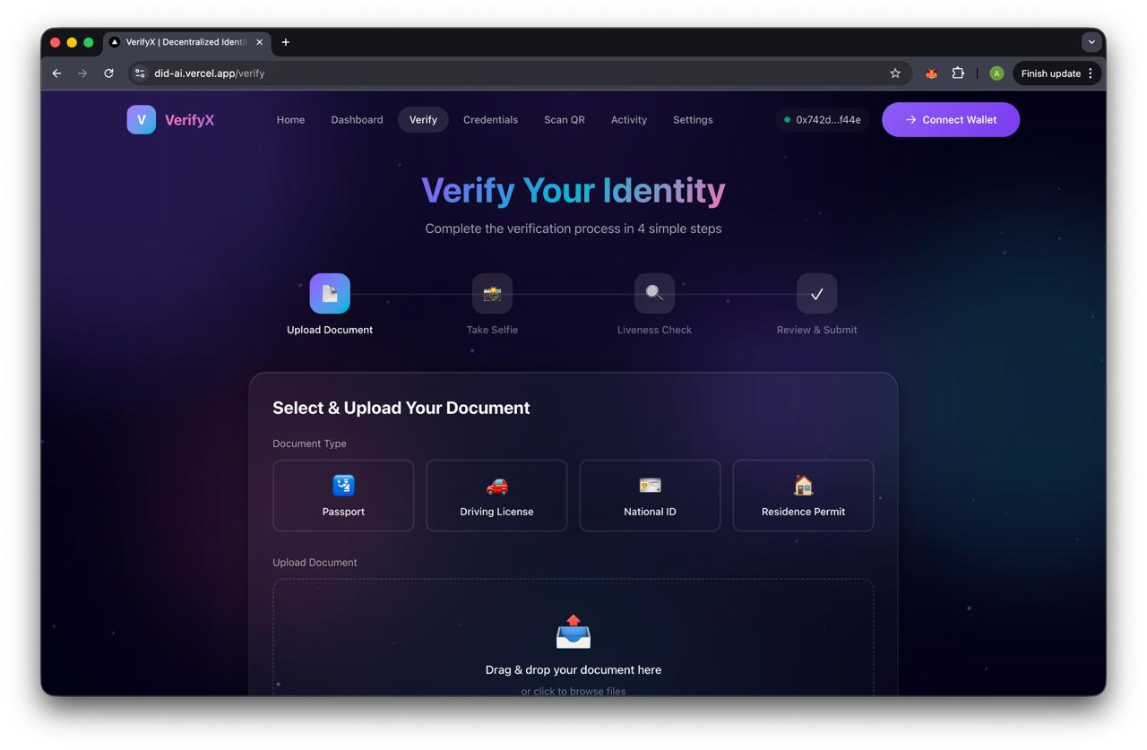
Figure 4.2: Identity Verification Workflow Screen
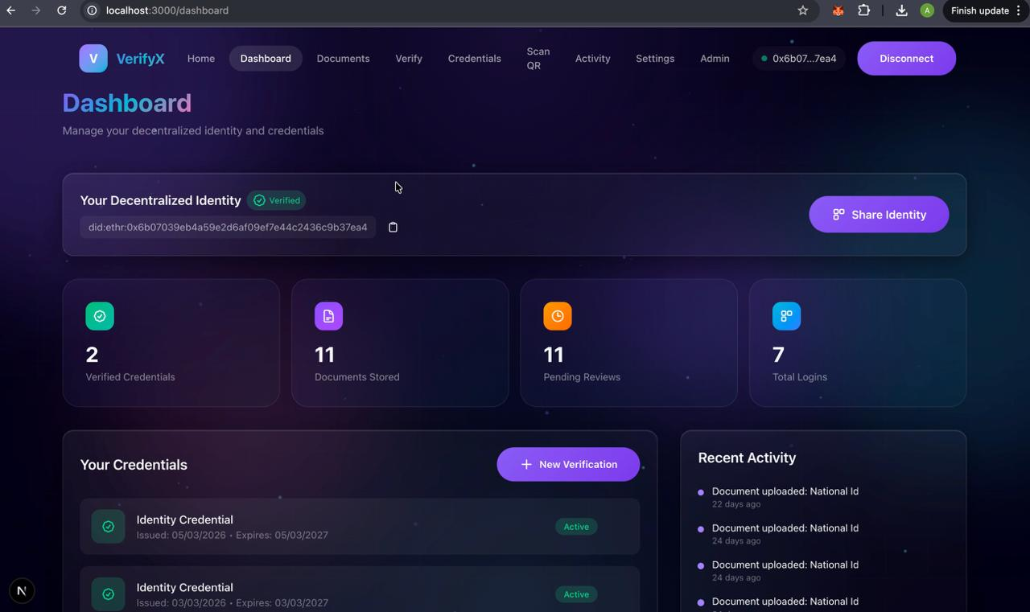
Figure 4.3: User Dashboard Interface
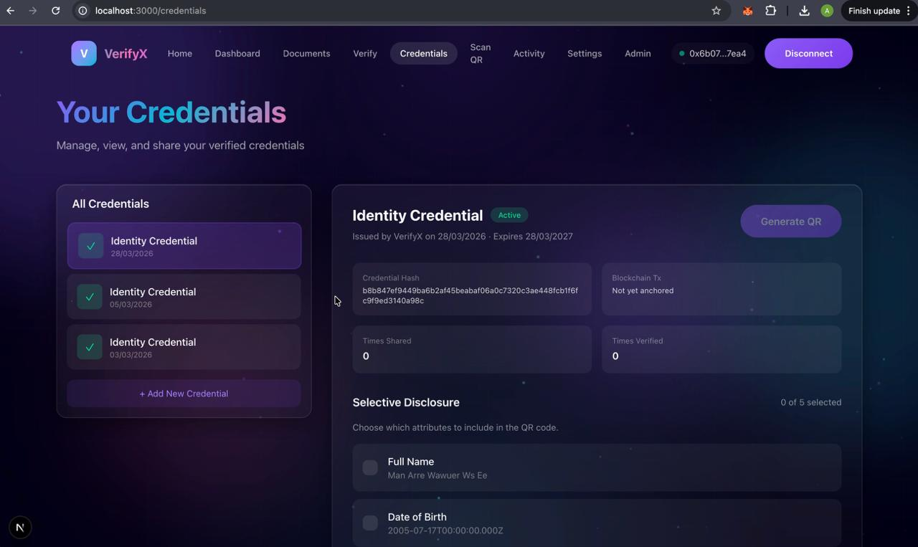
Figure 4.4: Credential Management Interface
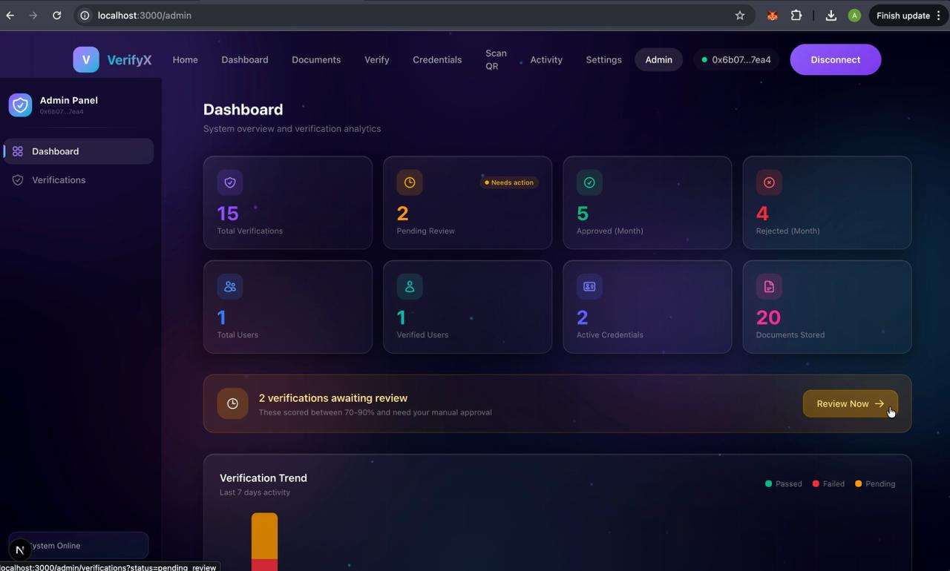
Figure 4.5: Admin Dashboard Interface
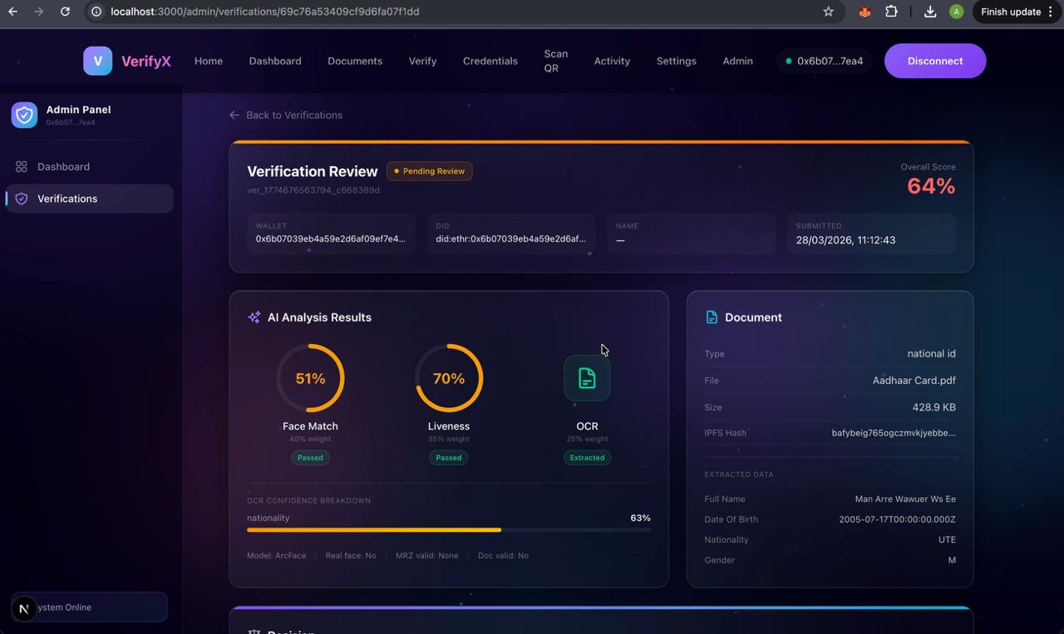
Figure 4.6: Verification Review Interface

4.2 Result Analysis:
1. The VerifyX system was successfully implemented and tested across core modules including user authentication, blockchain integration, and user interface. The wallet-based authentication using MetaMask functioned reliably, allowing users to securely log in through cryptographic signatures without the need for passwords. The nonce-based verification mechanism effectively prevented replay attacks and ensured secure session establishment.
2. The Decentralized Identifier (DID) generation and registration process was successfully executed using blockchain smart contracts. Each user was assigned a unique DID derived from their wallet address, and the DID documents were properly stored and retrieved from the blockchain. The system ensured immutability and integrity of identity data, demonstrating the reliability of decentralized identity management.
3. The blockchain integration module performed efficiently during testing. Smart contracts for DID Registry and Credential Registry were deployed and interacted with successfully using ethers.js. Credential hashing and transaction execution were validated on the local Ethereum network, confirming correct implementation of on-chain verification logic.
4. The user interface module provided a smooth and responsive experience. Users were able to connect their wallets, initiate authentication, and interact with system features without errors. The UI design ensured clarity and ease of use, supporting future integration of verification workflows and dashboards.
5. The system demonstrated stable performance during testing with consistent response times and accurate execution of authentication and blockchain operations. The modular architecture allowed independent testing of components, ensuring scalability and ease of future enhancements such as AI verification and decentralized storage.
4.3 Testing using Use Cases:
4.3.1 Authentication & Wallet Integration Module:
Sr No | Test Scenario | Input Condition | Expected Result | Status
1 | Wallet Not Connected | User tries to login without MetaMask | Error message prompting wallet connection | Valid
2 | Invalid Signature | Wrong signature provided | Authentication failed | Valid
3 | Valid Authentication | Correct wallet signature | User successfully logged in | Valid
4 | Replay Attack Attempt | Reuse of old nonce | Request rejected | Valid
5 | Wallet Disconnect | User disconnects wallet | Session terminated | Valid
Table 4.1: Test Cases for Authentication & Wallet Integration

4.3.2 DID Management Module:
Sr No | Test Scenario | Input Condition | Expected Result | Status
1 | DID Creation | New wallet address | DID generated and stored on blockchain | Valid
2 | Duplicate DID | Existing wallet tries again | Error: DID already exists | Valid
3 | DID Retrieval | Valid wallet address | DID document fetched successfully | Valid
4 | Invalid Address | Incorrect wallet address | Error message displayed | Valid
5 | DID Status Check | Active DID | Status shown as active | Valid
Table 4.2: Test Cases for DID Management

4.3.3 Document Management Module:
Sr No | Test Scenario | Input Condition | Expected Result | Status
1 | Empty File Upload | No file selected | Error message displayed | Valid
2 | Invalid File Type | Unsupported format | File rejected | Valid
3 | Valid Upload | Proper document uploaded | File encrypted and stored in IPFS | Valid
4 | Large File Upload | Large size document | Successfully processed | Valid
5 | Document Retrieval | Valid document ID | File fetched and decrypted | Valid
Table 4.3: Test Cases for Document Management

4.3.4 AI-Powered Verification Module:
Sr No | Test Scenario | Input Condition | Expected Result | Status
1 | Face Match Success | Same person images | Verification passed | Valid
2 | Face Mismatch | Different person images | Verification failed | Valid
3 | Liveness Check Pass | Real-time face input | Liveness confirmed | Valid
4 | Spoof Attempt | Photo/video used | Detection failed | Valid
5 | OCR Extraction | Valid document image | Data extracted correctly | Valid
Table 4.4: Test Cases for AI-Powered Verification

4.3.5 Credential Management Module:
Sr No | Test Scenario | Input Condition | Expected Result | Status
1 | Credential Issuance | Successful verification | Credential created | Valid
2 | Credential Hashing | Valid credential data | Hash stored on blockchain | Valid
3 | Credential Retrieval | Valid user request | Credential fetched | Valid
4 | Credential Revocation | Revoke request | Credential marked revoked | Valid
5 | Expired Credential | Past expiry date | Status shown as expired | Valid
Table 4.5: Test Cases for Credential Management
4.3.6 Selective Disclosure & QR Module:
Sr No | Test Scenario | Input Condition | Expected Result | Status
1 | QR Generation | Valid credential | QR code generated | Valid
2 | Attribute Selection | Select limited fields | Only selected data shared | Valid
3 | QR Verification | Scan valid QR | Credential verified | Valid
4 | Expired QR | Time exceeded | Access denied | Valid
5 | Unauthorized Access | Invalid scan | Verification failed | Valid
Table 4.6: Test Cases for Selective Disclosure & QR Module
4.3.7 Blockchain Integration Module:
Sr No | Test Scenario | Input Condition | Expected Result | Status
1 | Smart Contract Deployment | Deploy contracts | Successful deployment | Valid
2 | DID Registration | Valid transaction | Recorded on blockchain | Valid
3 | Credential Storage | Valid hash | Stored successfully | Valid
4 | Transaction Failure | Low gas / invalid tx | Transaction rejected | Valid
5 | Event Listening | Contract event triggered | Event captured | Valid
Table 4.7: Test Cases for Blockchain Integration
4.3.8 User Dashboard Module:
Sr No | Test Scenario | Input Condition | Expected Result | Status
1 | Dashboard Load | Logged-in user | Dashboard displayed | Valid
2 | Credential Display | User credentials exist | Credentials shown | Valid
3 | Empty State | No credentials | Message displayed | Valid
4 | Navigation | Click different sections | Proper redirection | Valid
5 | Activity Logs | User actions | Logs displayed correctly | Valid
Table 4.8: Test Cases for User Dashboard Module

4.3.9 Admin Module:
Sr No | Test Scenario | Input Condition | Expected Result | Status
1 | Admin Login | Valid credentials | Admin dashboard opened | Valid
2 | User Management | View users | User list displayed | Valid
3 | Verification Review | Pending requests | Requests visible | Valid
4 | System Configuration | Update settings | Changes applied | Valid
5 | Report Generation | Generate report | Report created successfully | Valid
Table 4.9: Test Cases for Admin Module

Chapter 5: Conclusion & Future work
5.1 Conclusion:
The AI-Enhanced Decentralized Identity Verification System was developed with the primary objective of providing a secure, privacy-preserving, and user-controlled digital identity solution. The system effectively addresses key challenges in traditional identity verification systems such as centralized data storage, risk of data breaches, repeated KYC processes, and lack of user control over personal information.
The platform is built using a modern and scalable architecture, integrating Next.js for the frontend, Node.js for backend services, Python-based AI modules for verification, and Ethereum blockchain for decentralized trust management. This combination ensures both performance efficiency and high security.
Key achievements of the implementation include:
- Decentralized Identity Management:
The system successfully generates and manages Decentralized Identifiers (DIDs) linked to user wallet addresses, ensuring a unique and tamper-proof digital identity stored on the blockchain.
- Secure Authentication Mechanism:
Wallet-based authentication using MetaMask eliminates the need for traditional passwords, leveraging cryptographic signatures and nonce-based verification to ensure strong security and resistance against replay attacks.
- Blockchain-Based Credential Verification:
Identity credentials are securely hashed and stored on the blockchain, ensuring immutability, transparency, and easy verification without exposing sensitive user data.
- User-Centric Privacy Model:
The system follows a self-sovereign identity approach where users have full control over their data and can selectively share only required information using secure mechanisms.
- Scalable and Modular Architecture:
The modular design enables easy integration of advanced features such as AI-based verification, decentralized storage, and QR-based credential sharing, ensuring future scalability and extensibility.
Compared to traditional identity verification systems, this system provides a more secure, decentralized, and privacy-focused approach. By combining blockchain technology with artificial intelligence and modern web frameworks, the system enhances trust, reduces dependency on centralized authorities, and empowers users with full ownership of their digital identity.
5.2 Future work:
While the AI-Enhanced Decentralized Identity Verification system currently provides a strong foundation for decentralized identity verification using blockchain and authentication mechanisms, several opportunities exist for further enhancement and scalability:
- AI-Based Identity Verification:
The system can be extended by fully integrating AI modules such as face verification, liveness detection, and OCR-based document validation. These enhancements will enable automated, accurate, and fraud-resistant identity verification.
- Decentralized Storage Integration:
Future implementation includes integrating IPFS for secure and decentralized storage of encrypted identity documents. This will ensure data integrity, availability, and user-controlled access without relying on centralized storage systems.
- Selective Disclosure & Privacy Enhancements:
Advanced privacy techniques such as Zero-Knowledge Proofs (ZKP) can be incorporated to allow users to verify specific attributes (e.g., age verification) without revealing complete personal information, enhancing privacy and compliance.
- Multi-Platform Accessibility:
Currently implemented as a web-based system, the platform can be extended to mobile applications (Android/iOS) to provide better accessibility, real-time notifications, and improved user experience.
- Multi-Blockchain Support:
The system can be enhanced to support multiple blockchain networks such as Polygon or Solana to reduce transaction costs and improve scalability while maintaining interoperability.
- Integration with Real-World Systems:
Future versions can integrate with government systems, banking services, and enterprise platforms to enable real-world adoption for KYC, onboarding, and identity verification use cases.
- Advanced Security & Compliance Features:
Enhancements such as biometric authentication, audit mechanisms, and compliance with global standards like GDPR and digital identity regulations can be implemented to strengthen system reliability and trust.

Chapter 6: References
[1] W3C, “Decentralized Identifiers (DIDs) v1.0,” 2022. [Online]. Available: https://www.w3.org/TR/did-core/
[2] W3C, “Verifiable Credentials Data Model v1.1,” 2021. [Online]. Available: https://www.w3.org/TR/vc-data-model/
[3] Ethereum Foundation, “Ethereum Developer Documentation,” [Online]. Available: https://ethereum.org/en/developers/docs/
[4] Solidity Team, “Solidity Documentation,” [Online]. Available: https://docs.soliditylang.org/
[5] Ethers.js, “Ethers.js Documentation,” [Online]. Available: https://docs.ethers.org/v6/
[6] MetaMask, “MetaMask Developer Documentation,” [Online]. Available: https://docs.metamask.io/
[7] Protocol Labs, “IPFS Documentation,” [Online]. Available: https://docs.ipfs.tech/
[8] S. Serengil, “DeepFace: A Lightweight Face Recognition Library for Python,” [Online]. Available: https://github.com/serengil/deepface
[9] Google, “MediaPipe Documentation,” [Online]. Available: https://developers.google.com/mediapipe
[10] Google, “Tesseract OCR Engine,” [Online]. Available: https://github.com/tesseract-ocr/tesseract
[11] MongoDB, Inc., “MongoDB Manual,” [Online]. Available: https://www.mongodb.com/docs/manual/
[12] OpenJS Foundation, “Node.js Documentation,” [Online]. Available: https://nodejs.org/en/docs
[13] Vercel, “Next.js Documentation,” [Online]. Available: https://nextjs.org/docs

